**Quantitative Methods**

**List of Exercises N. 5**

**Selected Exercises from McClave (2014) - Chapter 7**

**7.2 Formulating Hypothesis And Setting Up the Rejection Region**

**Exercise 1. (15). *FDA certification of new drugs*. According to Chemical Marketing Reporter, pharmaceutical companies spend USD 15 billion per year on research and development of new drugs. The pharmaceutical company must subject each new drug to lengthy and involved testing before receiving the necessary permission from the Food and Drug Administration (FDA) to market the drug. The FDA’s policy is that the pharmaceutical company must provide substantial evidence that a new drug is safe prior to receiving FDA approval, so that the FDA can confidently certify the safety of the drug to potential consumers.**

1. **If the new drug testing were to be placed in a test of hypothesis framework, would the null hypothesis be that the drug is safe or unsafe? The alternative hypothesis?**

Since the company must give proof the drug is safe, the null hypothesis would be the drug is unsafe. The alternative hypothesis would be the drug is safe.

H0 = The drug is unsafe

H1 = The drug is safe

So our status quo is that the drug is not safe, this is also why it is not on the market yet. The company must give proof that the drug is safe. You are researching if the drug is safe. Therefore, the alternative hypothesis is that ‘the drug is safe’, because this is what you are conducting your research to find out.

1. **Given the choice of null and alternative hypothesis in part a, describe Type I and Type II errors in terms of this application. Define α and β I terms of this application.**

A Type error would be concluding the drug is safe, when it is not safe. So rejecting the null hypothesis, when it is true.

A Type II error would be concluding the drug is not safe, when it is. So accepting the null hypothesis, when it is false.

α is the probability of concluding the drug is safe, when it is not. In other words, the probability of committing a Type I error.

β is the probability of concluding the drug is not safe, when it is. In other words, the probability of committing a Type II error.

1. **If the FDA wants to be very confident that the drug is safe before permitting it to be marketed, is it more important that α or β be small? Explain.**

In this problem, it would be more important for α to be small. We would want the probability of concluding the drug is safe, when it is not to be as small as possible.

Hypothetically the drug might be very dangerous and kill people. If it was released to the public without being safe, this means it could kill people. If it is not released even though it is safe, it means that the company loses its investment but nobody is injured.

**Exercise 2. (16). *Authorizing computer users*. At high-technologies industries, computer security is achieved by using a password – a collection of symbols (usually letters and numbers) that must be supplied by the user before the computer permits access to the account. The problem is that persistent hackers can create programs that enter millions of combinations of symbols into a target system until the correct password is found. The newest systems solve this problem by requiring authorized users to identify themselves by unique body characteristics. For example, a system developed by Palmguard Inc. tests the hypothesis**

**H0: The proposed user is authorized**

**Ha: The proposed user is unauthorized**

**by checking characteristics of the proposed user’s palm against those stored in the authorized users’ data bank.**

1. **Define a Type I error and Type II error for this test. Which is the more serious error? Why?**

Remember, rejecting the null hypothesis when it is in fact true is called a Type I error. Not rejecting the null hypothesis, when in fact the alternative hypothesis is true is called Type II error.

A Type I error would be concluding the proposed user is unauthorized, when in fact the proposed user is authorized.

A Type II error would be concluding the proposed user is authorized, when in fact the proposed user is unauthorized.

In this case, a more serious error would be a Type II error. One would not want to conclude that the proposed user is authorized, when he or she is not.

1. **Palmguard reports that the Type I error rate for its system is less than 1%, whereas the Type II error rate is 0.00025%. Interpret these error rates.**

The Type I error rate is 1%. This means that the probability of concluding the proposed user is unauthorized when, in fact, the proposed user is authorized is 0.01.

The Type II error rate is 0.00025%. This means that the probability of concluding the proposed user is authorized when, in fact, the proposed user is unauthorized is 0.000025.

1. **Another successful security system, the EyeDentifier, “spots authorized computer users by reading the one-of-a-kind patterns formed by the network of minute blood vessels across the retina at the back of the eye.” The EyeDentifyer reports Type I and II error rates of 0,01% (1 in 10.000) and 0,005% (5 in 100.000), respectively. Interpret these rates.**

The Type I error rate is 0.01%. This means that the probability of concluding the proposed user is unauthorized when, in fact, the proposed user is authorized is 0.0001.

The Type II error rate is 0.005%. This means that the probability of concluding the proposed user is authorized when, in fact, the proposed user is unauthorized is 0.00005.

**7.4 Test of Hypothesis about a Population Mean: Normal z – Statistic**

**Exercise 3. (41). *Point spreads of NFL games.* During the National Football League (NFL) season, Las Vegas odds makers establish a point spread on each game for betting purposes. For example, the New England Patriots were established as 3,5 – point favorites over eventual champion New York Giants in the 2012 Super Bowl. The final scores of NFL games were compared against the final point spreads established by the odds makers in Chance (Fall 1998). The difference between the game outcome and point spread (called a point-spread error) was calculated for 240 NFL games. The mean and standard deviation of the point-spread errors are $\overline{x}$ = -1,6, s = 13,3. Use this information to test the hypothesis that the true mean point-spread error for all NFL games differs from 0. Conduct the test at α = 0,01 and interpret the result.**

To determine if the mean point-spread error is different from 0, we test:

$$H_{0}:μ=0$$

$$H_{a}:μ≠0$$

The test statistic is:

$$z=\frac{\overline{x}-μ_{0}}{σ_{\overline{x}}}=\frac{\overline{x}-μ}{σ/\sqrt{n}}$$

See page 325 for further information about the z-test.

$$z=\frac{-1.6-0}{13.3/\sqrt{240}}=-1.86$$

In R: (-1.6-0)/(13.3/sqrt(240))

Result: -1.863691

The rejection region requires α/2=0.01/2 = 0.005 in each tail of the z-distribution. From the z-table, we can see that z0.005=2.575. The rejection region is z < -2.575 or z>2.575. Since the observed value of the test statistic does not fall in the rejection region (z=-1.86≠-2.575), H0 is not rejected. There is insufficient evidence to indicate that the true mean point-spread error is different from 0 at alpha=0.01.

**Exercise 4. (42, NFDA). *Revenue for a full-service funeral.* According to the National Funeral Directors Assosciation (NFDA), the nation’s 22,000 funeral homes collected an average of 6,500 USD per full service funeral in 2009 (**[**www.nfda.org**](http://www.nfda.org)**). A random sample of 36 funeral homes reported revenue data for the current year. Among other measures, each reported its average fee for a full-service funeral. These data (in thousands of dollars) are shown in the following table.**

|  |  |  |  |  |  |  |  |  |
| --- | --- | --- | --- | --- | --- | --- | --- | --- |
| **7.4** | **9.4** | **5.3** | **8.4** | **7.5** | **6.5** | **6.2** | **8.3** | **6.7** |
| **11.6** | **6.3** | **5.9** | **6.7** | **5.8** | **5.2** | **6.4** | **6.0** | **7.4** |
| **7.2** | **6.6** | **6.3** | **5.3** | **6.6** | **5.6** | **8.4** | **7.2** | **7.4** |
| **5.8** | **6.3** | **6.1** | **7.0** | **7.2** | **6.1** | **5.4** | **7.4** | **6.6** |

First, we need to do as followed:

1. Clean your screen
2. Import data
3. Create variables
4. Run Library(mosaic)

For explanation how to do this look at List 1, Exercise 1.

Clean R Script: rm(list=ls())

Library: library(mosaic)

Import data or create the data in R:

FuneralHomes<-c(7.4,9.4,5.3,8.4,7.5,6.5,6.2,8.3,6.7,11.6,6.3,5.9,6.7,5.8,5.2,6.4,6.0,7.4,7.2,6.6,6.3,5.3,6.6,5.6,8.4,7.2,7.4,5.8,6.3,6.1,7.0,7.2,6.1,5.4,7.4,6.6)

Create variable: FuneralHomes<- FuneralHomes

**a) What are the appropriate null and alternative hypothesis to test whether the average full-service fee of US funeral homes this year exceeds 6.500 USD?**

Let µ = average full-service fee (in thousands of dollars) of U.S. funeral homes in the current year. To determine if the average full-service fee exceeds $6,500, we test:

$$H_{0}:μ=6.50$$

$$H_{a}:μ≠6.50$$

In other words, H0 = the average full-service fee is equal to 6500 dollars, and H1 = average full service fee is more than 6500 dollars. This is thus a one-tailed test.

**b) Conduct the test at α = 0,05. Do the sample data provide sufficient evidence to conclude that the average fee this year is higher than in 2009?**

In this exercise, we need the mean and standard deviation, as we are going to calculate the test statistic, See page 325 for more information:

$$z=\frac{\overline{x}-μ_{0}}{σ_{\overline{x}}}=\frac{\overline{x}-μ}{σ/\sqrt{n}}$$

In R: favstats(FuneralHomes)

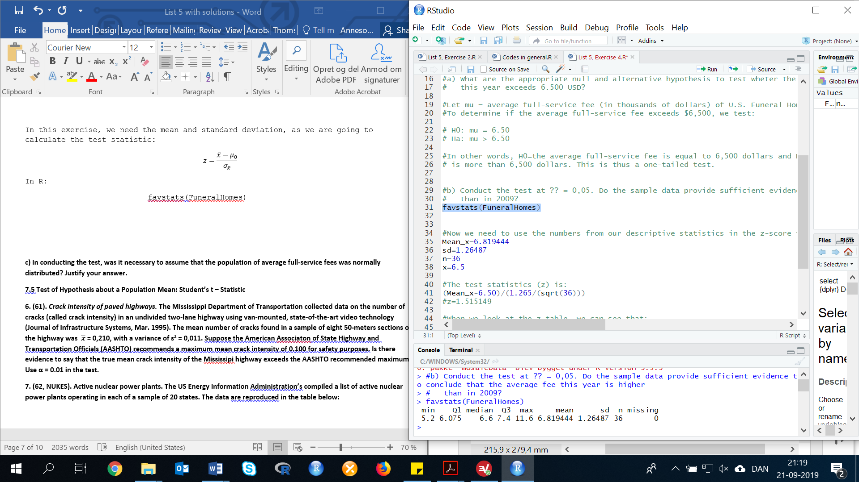

Now we need to use the numbers from our descriptive statistics in the z-score formula. The test statistics (z) is:

(6.819444-6.5)/(1.26487/sqrt(36))

Result: 1.515305

The rejection region requires α = 0.05 in the upper tail of the z-distribution. From the z-table, we can see that z0.05=1.645. The rejection region is z > 1.645.

Since the observed value of the test statistic does not fall in the rejection (z=1.51≠1.645), H0 is not rejected. There is insufficient evidence to indicate the true mean full-service fee of U.S. funeral homes in the current year exceeds $6,500 at α=0.05.

**c) In conducting the test, was it necessary to assume that the population of average full-service fees was normally distributed? Justify your answer.**

No. Since the sample size (n=36) is greater than 30, the Central Limit Theorem applies. The distribution of $\overline{x}$ is approximately normal regardless of the population distribution.

**7.5 Test of Hypothesis about a Population Mean: Student’s t – Statistic**

**Exercise 5. (61). *Crack intensity of paved highways.* The Mississippi Department of Transportation collected data on the number of cracks (called crack intensity) in an undivided two-lane highway using van-mounted, state-of-the-art video technology (Journal of Infrastructure Systems, Mar. 1995). The mean number of cracks found in a sample of eight 50-meters sections of the highway was $\overline{x}$ = 0,210, with a variance of s2 = 0,011. Suppose the American Associaton of State Highway and Transportation Officials (AASHTO) recommends a maximum mean crack intensity of 0.100 for safety purposes. Is there evidence to say that the true mean crack intensity of the Mississipi highway exceeds the AASHTO recommended maximum? Use α = 0.01 in the test.**

To determine if the true mean crack intensity of the Mississippi highway exceeds the AASHTO recommended maximum, we test:

$$H_{0}:μ=0.100$$

$$H_{a}:μ>0.100$$

The test statistic is (see page 325 for more information):

$$t=\frac{\overline{x}-μ_{0}}{s/\sqrt{n}}$$

$$t=\frac{0.210-0.100}{\sqrt{0.011}/\sqrt{8}}=2.966479$$

In R:

(0.210-0.100)/(sqrt(0.011)/sqrt(8))

Result: 2.966479

The rejection region requires α=0.01 in the upper tail of the t-distribution with df=n-1=8-1=7. From the t table, we can see that t0.01=2.998. The rejection region is t>2.998.

Since the observed value of the test statistic does not fall in the rejection region (t=2.97≠2.998), H0 is not rejected. There is insufficient evidence to indicate that the true mean crack intensity of the Mississippi highway exceeds the AASHTO recommended maximum at α = 0.01.

**Exercise 6. (62, NUKES). Active nuclear power plants. The US Energy Information Administration’s compiled a list of active nuclear power plants operating in each of a sample of 20 states. The data are reproduced in the table below:**

|  |  |  |  |
| --- | --- | --- | --- |
| **State** | **N. of Power Plants** | **State** | **N. of Power Plants** |
| **Alabama** | **5** | **New Hampshire** | **1** |
| **Arizona** | **2** | **New York** | **6** |
| **California** | **4** | **North Carolina** | **5** |
| **Florida** | **5** | **Ohio** | **3** |
| **Georgia** | **4** | **Pennsylvania** | **9** |
| **Illinois** | **11** | **South Carolina** | **7** |
| **Kansas** | **1** | **Tennessee** | **3** |
| **Louisiana** | **2** | **Texas** | **4** |
| **Massachusetts** | **1** | **Vermont** | **1** |
| **Mississippi** | **1** | **Wisconsin** | **3** |

First, we need to do as followed:

1. Clean your screen
2. Import data
3. Create variables
4. Run Library(mosaic)

For explanation how to do this look at List 1, Exercise 1.

Clean R Script: rm(list=ls())

Library: library(mosaic)

Import data from Excel: library(readxl)

L5E6 <- read_excel("~/SDC/Quantitative Research Methods Course/Exercises/Dataset/List5/L5E6.xlsx")

View(L5E6)

attach(L5E6)

Create variables: STATE <- STATE

PLANTS <- PLANTS

1. **Is there sufficient evidence to claim that the mean number of active nuclear power plants operating in all states exceeds 3? Test using α = 0.10.**

In this exercise, we use the t-test as the n is smaller than 30. Here, we want to compare the mean of each state with 3.

To conduct the test we must set up a hypothesis and a null hypothesis:

$$H_{0}:μ=3$$

$$H_{a}:μ>3$$

In other words, Let µ=mean number of active nuclear power plants operating in all states. To determine if the mean number of active nuclear power plants operation in all states exceeds 3.

To solve this exercise, we need to calculate the mean and standard deviation. To do this, we use the following method:

favstats(PLANTS)

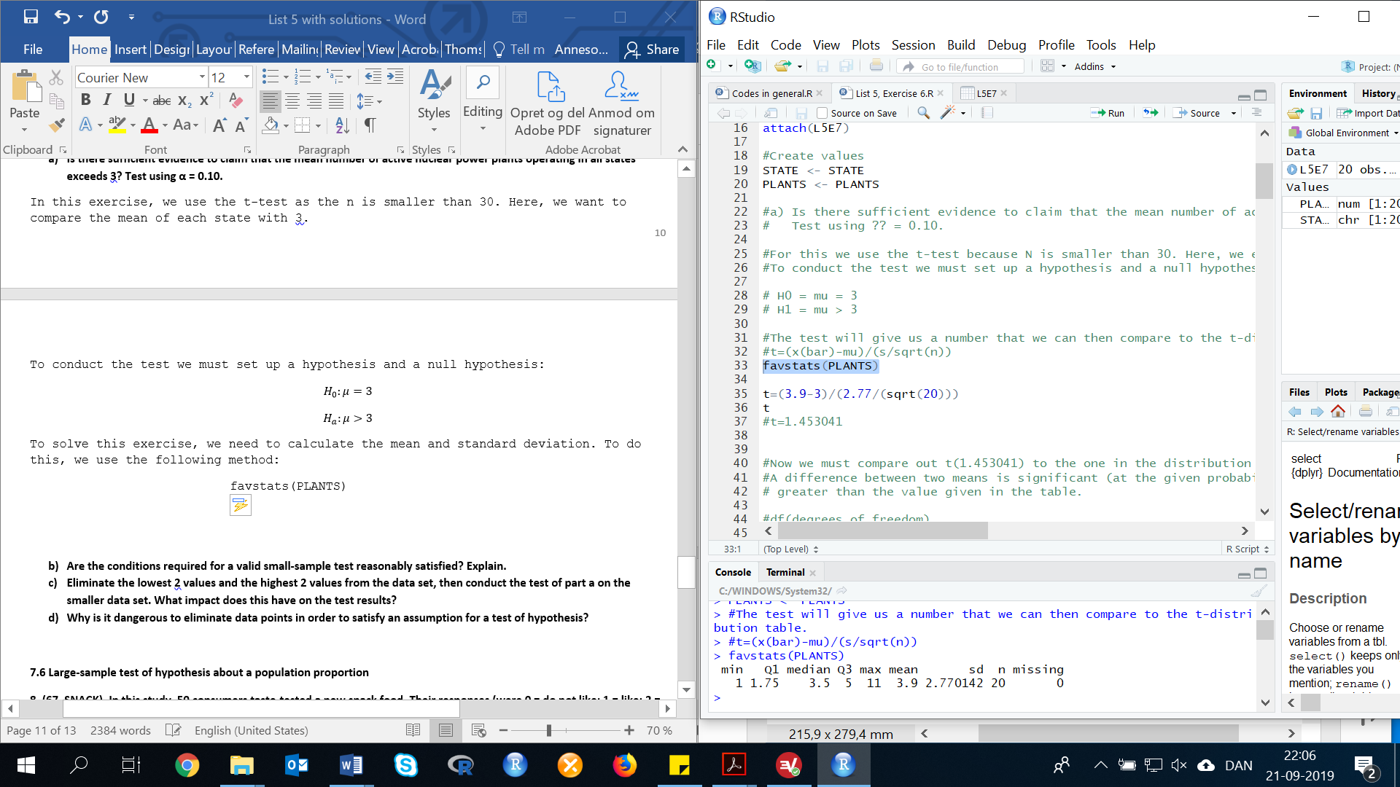

The test statistic is (see page 325 for more information):

$$t=\frac{\overline{x}-μ_{0}}{s/\sqrt{n}}$$

$$t=\frac{3.9-3}{2.770142/\sqrt{20}}=1.452966$$

The rejection region requires α=0.10 in the upper tail of the t-distribution with df=n-1=20-1=19. We are looking for a one-tail probability because our data is one-directional (we are look for the mean of 3 or above). From the t-table, we can see that: t0.10=1.328. The rejection region is t>1.328.

Remember, a difference between two means is significant (in this case, at the probability level α=0.10) if calculated t value is greater than the value given in the table.

Since the observed value of the test statistic falls in the rejection region (t=1.452966 > 1.328), H0 is rejected. There is sufficient evidence to indicate the mean number of active nuclear power plants operating in all states exceeds 3 at α = 0.10.

1. **Are the conditions required for a valid small-sample test reasonably satisfied? Explain.**

As we know, the number of observations are below 30 (in this case 21), therefore we cannot assume the sample to be normal distributed due to the central limit theorem. This means, we need to test if the data is normal distributed.

A requirement for both the t-test and the z-test is that our data is normal distributed.

To answer this question, we need to look at the different indications of a normal distributed sample. Therefore, we will look at the following five arguments:

1. Mean=median=mode
2. Bell shape form of a histogram
3. Kurtosis = 3, Skewness = 0
4. Empirical Rule
5. Interquartile Range = 1.3

Argument 1: Mean=median=mode

If we look at the descriptive statistics, we calculated in Exercise 7 part a, we can see that the mean and median are not equal.



However, we will also calculate the mode, just to be clear.

getmode <- function(v) {

uniqv <- unique(v)

uniqv[which.max(tabulate(match(v, uniqv)))]

}

mode <- getmode(PLANTS)

print(mode)

Result: mode = 1

Now look at the descriptive statistics. Due to the fact, that the mean, median and mode differ quite from each other. Therefore, this 1st argument would be an argument against normality.

Argument 2: Bell shape form of a histogram

Now we look at a histogram of the data.

gf_histogram( ~ PLANTS, data = L5E7)

The histogram looks skewed to the right. Thereby it does not seem to be normally distributed.

Argument 3: Kurtosis = 3, Skewness = 0

To Calculate the kurtosis and skewness, you need to install (if you have not done it before) and run/load the library fBasic.

Install.package(fBasics)

library(fBasics)

Now you can calculate the kurtosis and skewness.

The kurtosis tells you how tall and sharp the central peak is, relative to a standard bell shape histogram, in which the kurtosis equals approximately 3. The Skewness, as you know, describes to which side the histogram is skewed, hence without skewness(=0), the histogram would be centered around the mean instead into one specific side of the histogram. These two are measures of shape.

kurtosis(PLANTS)

skewness(PLANTS)

Result: Kurtosis = 0.154901

Skewness = 0.930885

Due to the fact, that both measurements do not approach the values they should in a normal distribution, this 3rd argument is an argument against normality.

Argument 4: the Empirical Rule

Next, we look at the intervals $\overline{x}±sd$, $\overline{x}±2sd$, and $\overline{x}±3sd$. If the proportions of observations falling in each interval are approximately .68, .95, and 1.00 then the data are approximately normal.

Mean=3.9 and the standard deviation (sd)=2.770142.

$$\overline{x}±sd$$

$$3.9±2.770142$$

Interval: (1.129858, 6.670142)

12 of the 20 values fall in this interval. The proportion is .60. This is smaller than the .68 we would expect if the data were normal.

$$\overline{x}±2sd$$

$$3.9±2*2.770142$$

Interval: (-1.640284, 9.440284)

19 of the 20 values fall in this interval. The proportion is .95. This is the same as the .95. we would expect if the data were normal.

$$\overline{x}±3sd$$

$$3.9±3*2.770142$$

Interval: (-4.410426, 12.21043)

20 of the 20 values fall in this interval. The proportion is 1.000. This is equal to the 1.00 we would expect if the data were normal.

From the first interval, it appears that the data might not be normal.

Argument 5: Interquartile Range = 1.3

From the favstats(PLANTS) calculation, we know the Q1 and Q3. With these quartiles, we can calculate the interquartile range.

IQR = Q3-Q1

IQR = 5-1.75 = 3.25

According to the empirical rule, the ratio of the Interquartile range to standard deviation is approximately 1.3. The IQR is where 50% of your data lays.

$$\frac{IQR}{sd}$$

$$\frac{3.25}{2.770142}=1.173225$$

This is close to the 1.3, we would expect if the data were normal. This method indicates the data may be normal.

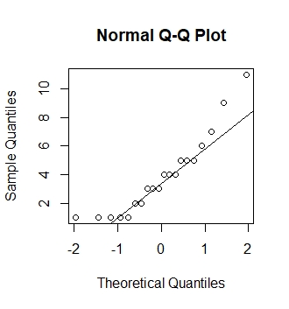Extra: normal probability plot

Finally, we could make a normal probability plot.

qqnorm(PLANTS)

qqline(PLANTS)

If the data were normal, the data points should follow the straight lines. Since it does not, it indicates that it is not normal. From the methods, the indications are that the number of power plants data are not normal.

1. **Eliminate the lowest 2 values and the highest 2 values from the data set, then conduct the test of part a on the smaller data set. What impact does this have on the test results?**

The two largest values are 9 and 11. The two lowest values are 1 and 1. Try to run the t-test again without these scores.

Similar to List 2, Exercise 3, we need to eliminate some values. To remove the 2 largest and 2 lowest values from the data set, you need to select the values. However, there is many different ways to do this in R. One of the ways is as following:

First, you need to look at the variable. If you type in the name of the variable, and press run it will show you all of the data points (values):

PLANTS



By looking at the data, we can see that the two largest values are 9 and 11, which is (if we count) the 19th and 20th value in this variable. To check, we can get R to show us if it is correct.

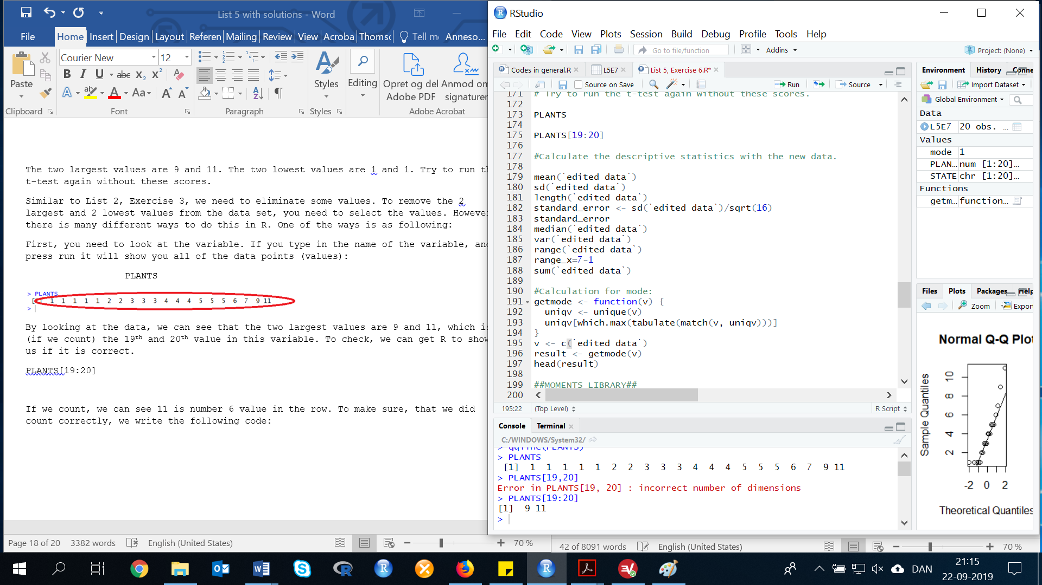PLANTS[19:20]

The two lowest values are 1 and 1, which could be two of the values between the 1st and the 5th values in this variable, as we can see below.

PLANTS[1:5]

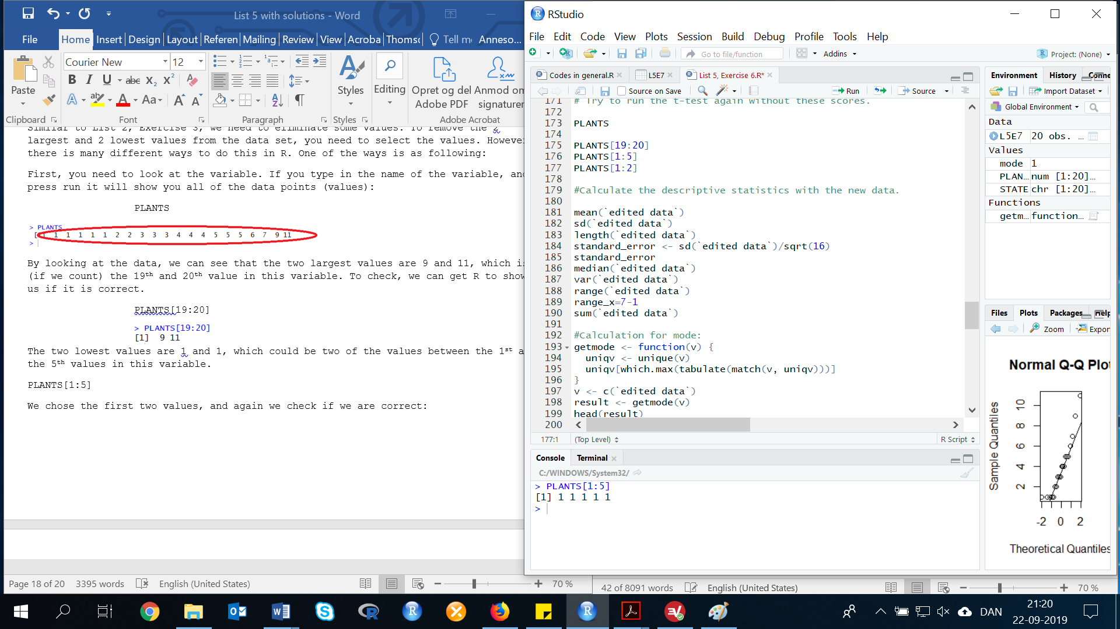

We chose the first two values, and again we check if we are correct:

PLANTS[1:2]

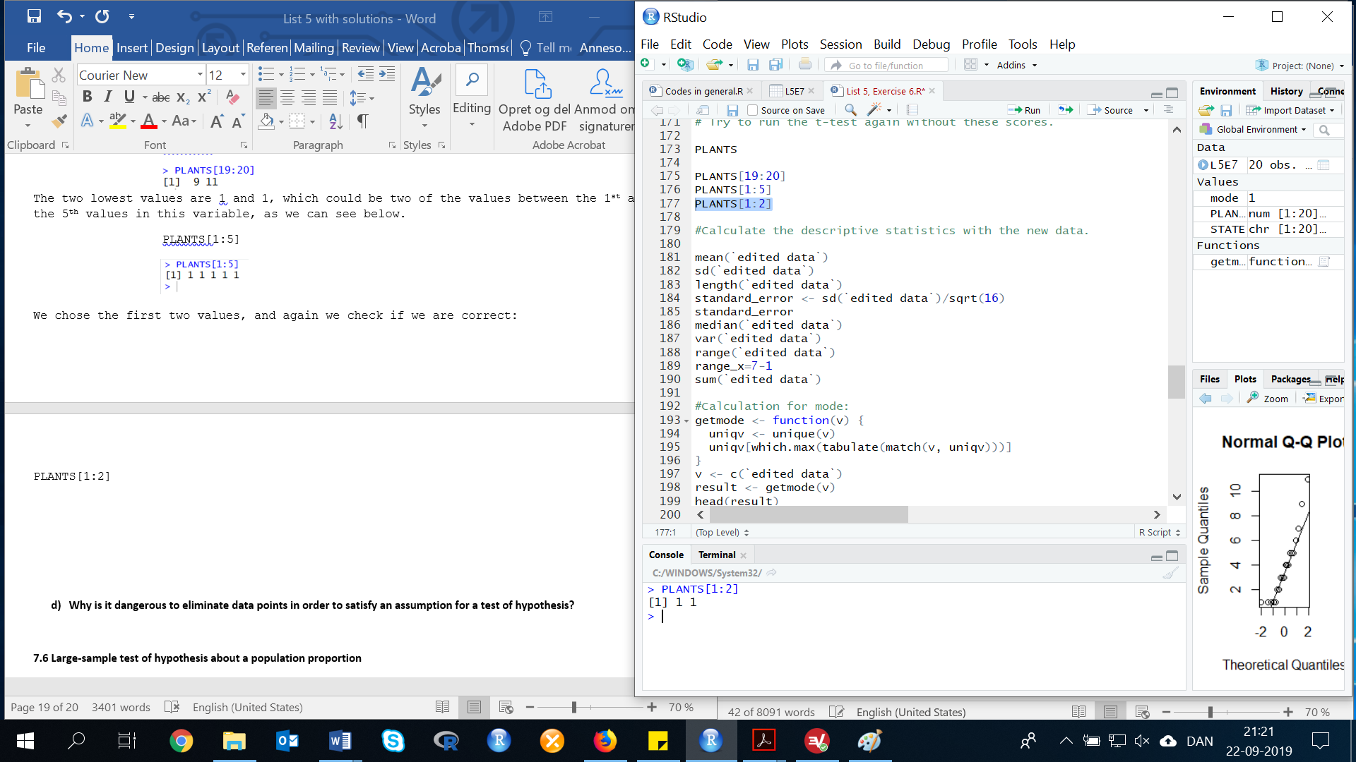

Those brackets [] illustrate another strong point of R. They represent a function that you can use to extract a value from that vector. There are many ways to remove values from an variables. However, we chose one of the most simplest ways:

First, we remove the highest values:

PLANTS[-(19:20)]

Create a new variable (without the highest values):

PLANTS_RHIGH <- PLANTS[-(19:20)]

Now we have removed, the 19th and 20th values. See below.

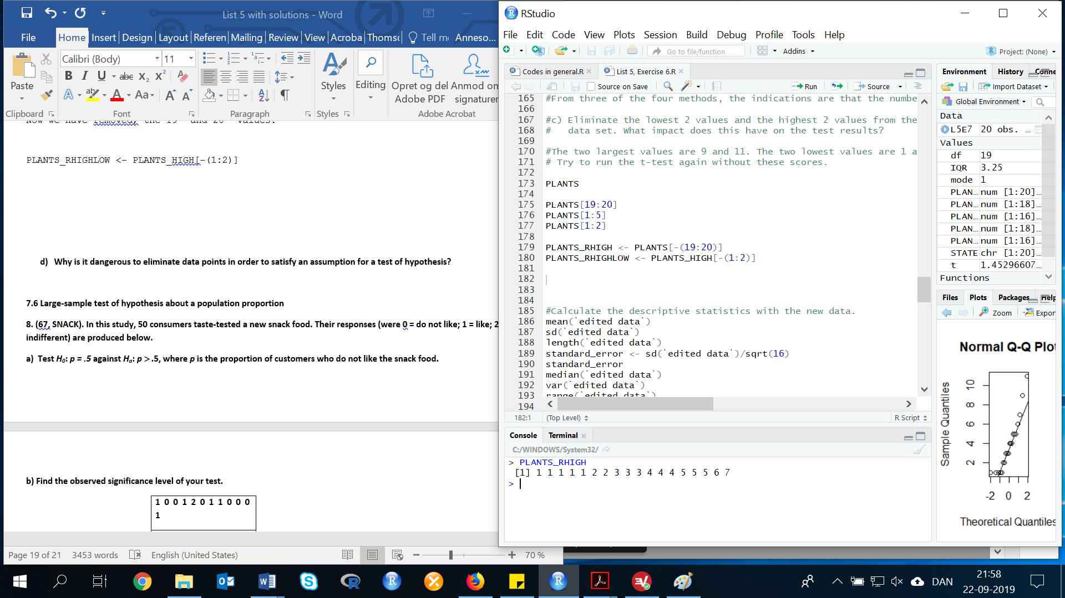

Now we just need to remove, the two lowest values:

PLANTS_HIGH[-(1:2)]

Create a new variable (without the lowest values):

PLANTS_RHIGHLOW <- PLANTS_HIGH[-(1:2)]

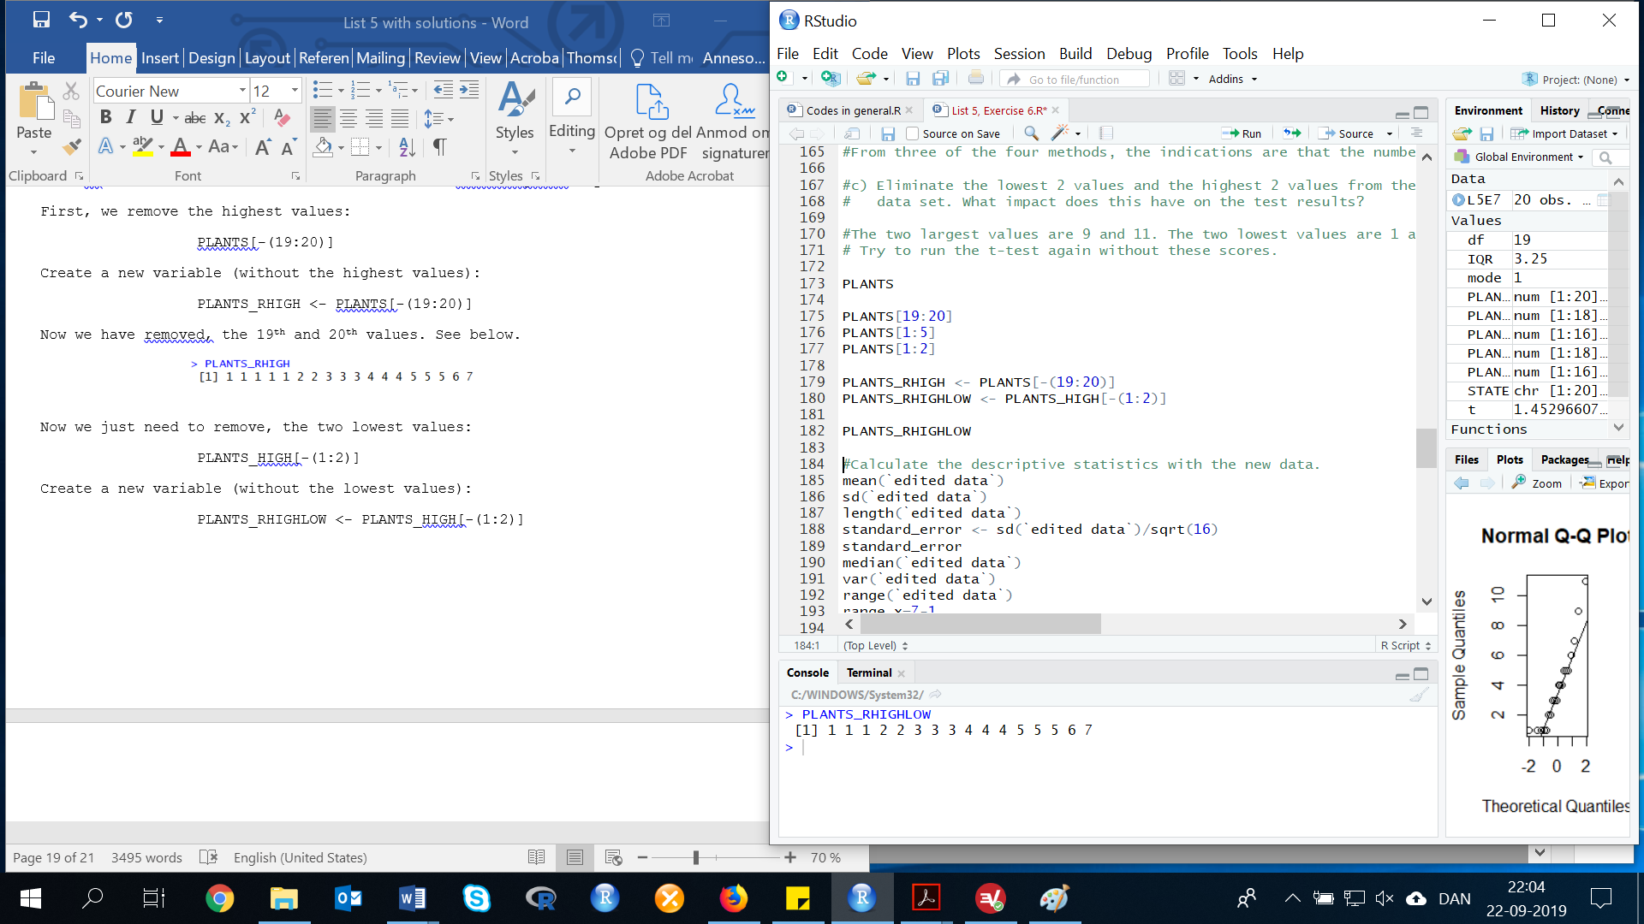Now we have the new variable for Plants (without the four values (1, 1, 9, 11)), which we have called PLANTS_RHIGHLOW:

To solve this exercise, we now need to use our new variable to make descriptive statistics:

favstats(PLANTS_RHIGHLOW)

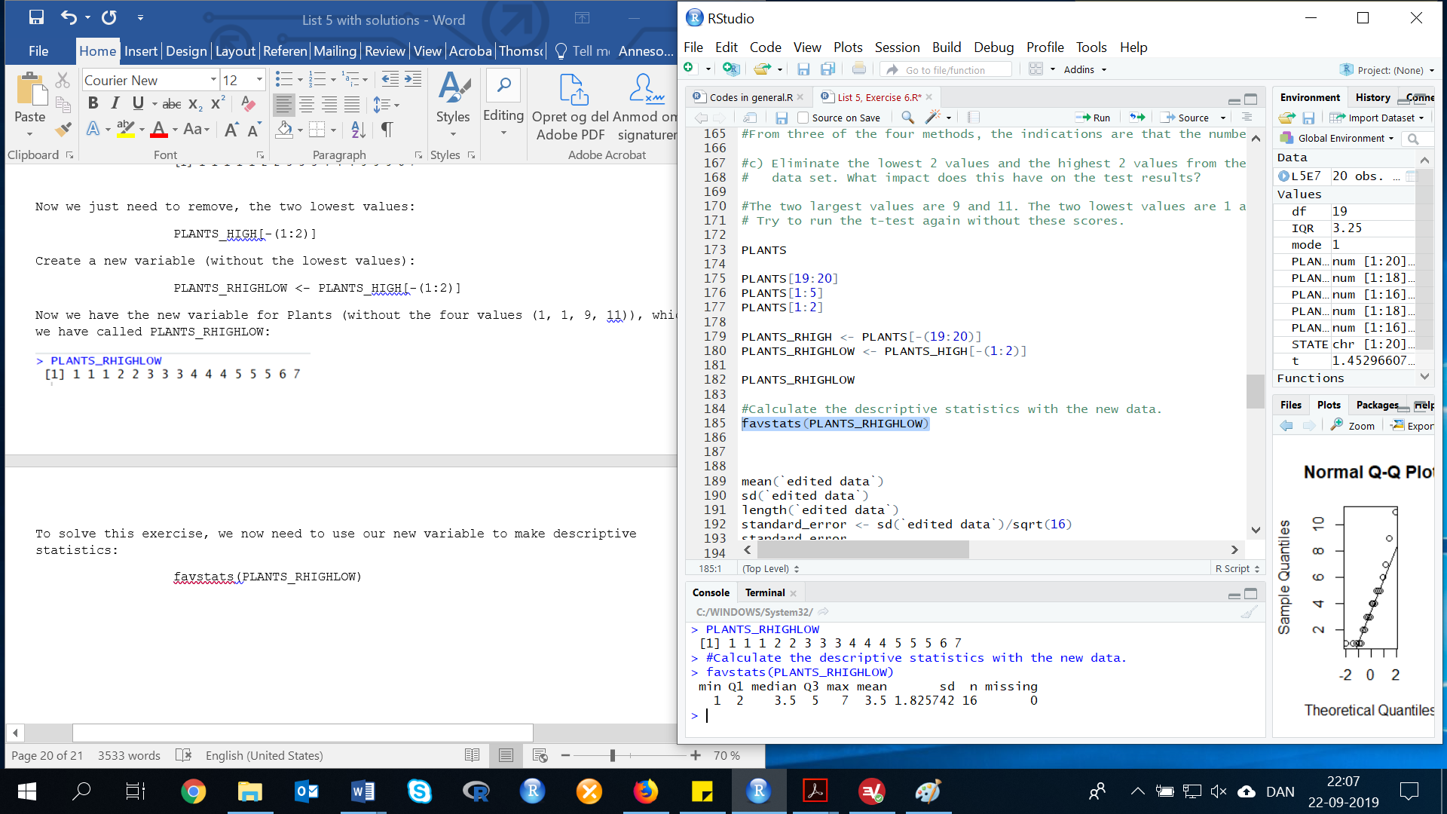

To determine if the mean number of active nuclear power plants operating in all states exceeds 3 (using the reduced data set), we test:

$$H_{0}:μ=3$$

$$H_{a}:μ>3$$

The test statistic is (see page 325 for more information):

$$t=\frac{\overline{x}-μ_{0}}{s/\sqrt{n}}$$

$$t=\frac{3.5-3}{1.825742/\sqrt{16}}=1.095445$$

Find your t on your t distribution table. Remember your df has changed because you deleted some values, it is now:

df=n-1

df=16-1=15



Since the observed value of the test statistic does not fall in the rejection region (t=1.095 differ 1.341), H0 is not rejected. There is insufficient evidence to indicate the mean number of active nuclear power plants operating in all states exceeds 3 at α=0.10.

By eliminating the top two and bottom two observations, we have changed the decision about H0.

1. **Why is it dangerous to eliminate data points in order to satisfy an assumption for a test of hypothesis?**

It is very dangerous to eliminate data points to satisfy assumptions. The data may, in fact, not be normal. By eliminating data points, one has changed the kind of data that come from the parent population. Thus, incorrect decisions could be made.

As a starting point, it is important to keep observations in your data set for testing.

However, you must also consider if some of your data may in fact be outliers or mistakes. For example, if you have data about people’s weight and one data-point is 888kg. this data point might skew your otherwise normal data. It would be acceptable to delete this data-point on the grounds that it is not possible for a human to weigh this much and that someone probably accidentally held down the 8-button.

There may also be less clear situations where you have data with outliers that skew your data and you will have to argue for or against keeping them in your data set for testing.

There also exist methods (with their own advantages and disadvantages) to transform your data so it becomes normal, but that’s not really covered in this course so don’t worry.

**7.6 Large-sample test of hypothesis about a population proportion**

**Exercise 7. (67, SNACK). In this study, 50 consumers taste-tested a new snack food. Their responses (were 0 = do not like; 1 = like; 2 = indifferent) are produced below.**

First, we need to do as followed:

1. Clean your screen
2. Run Library(mosaic)
3. Import data
4. Create variables

For explanation how to do this look at List 1, Exercise 1.

Clean the R Script: rm(list=ls())

Library: library(mosaic)

In this exercise, we have to import the data from List 4, Exercise 10.

Import data from Excel: library(readxl)

L4E10 <- read_excel("~/SDC/Quantitative Research Methods Course/Exercises/Dataset/List4/L4E10.xlsx")

View(L4E10)

attach(L4E10)

Create values: Sample <- Sample

**a) Test *H0*: *p = .5* against *Ha*: *p* >.5, where *p* is the proportion of customers who do not like the snack food.**

Remember:

“*A random sample of 50 consumers taste-tested a new snack food. Their responses were coded (0: do not like; 1: like; 2: indifferent)*” (List 4, Exercise 10).

From the data (List 4, Exercise 10) we know that n=50, and since p is the proportion of consumers who do not like the snack food, $\hat{p}$ will be:

$$\hat{p}=\frac{Number of 0^{'}s in the sample}{n}$$

To figure out, how many consumers do not like the snack food, we can use many different methods. In this exercise, we will give you two ways of doing it:

First, we can look at the data:

Sample

sort(Sample)

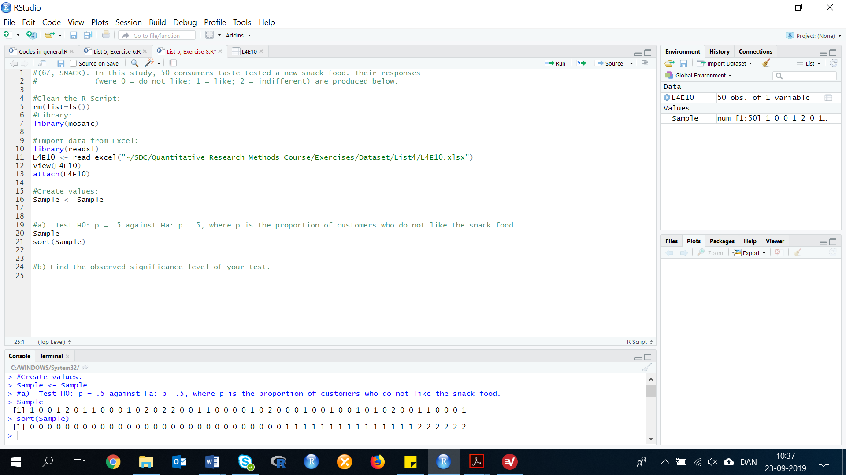

Now, we can count the number of 0’s in the sample. By counting the values, we identify 29 values that are equal to 0.

Second, we can filter our data:

filter(L4E10, Sample =='0')

Not_Like <- filter(L4E10, Sample =='0')

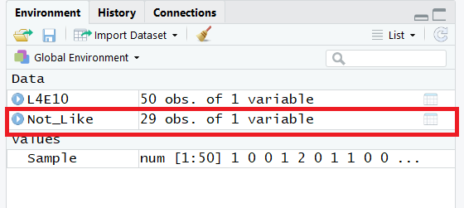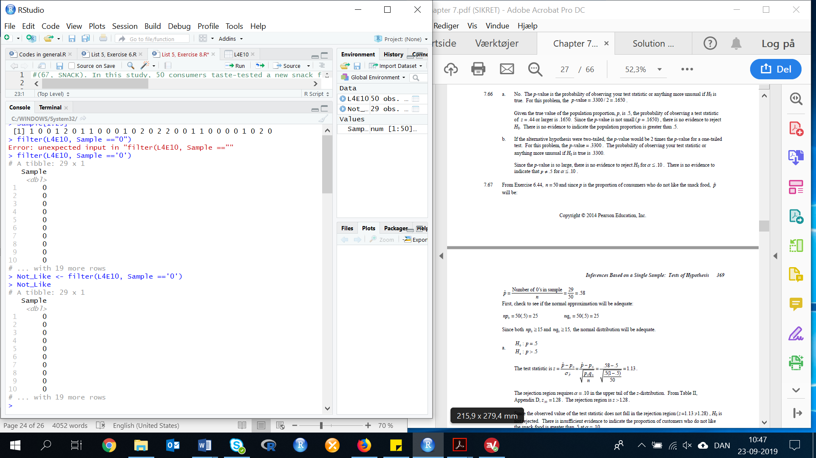

This method also gives us 29 observations (29 consumers who do not like the snack food).

We will use this data to calculate the $\hat{p}$:

$$\hat{p}=\frac{Number of 0^{'}s in the sample}{n}=\frac{29}{50}=0.58$$

First, check to see if the normal approximation will be adequate:

$$np_{0}=50*0.5=25$$

$$nq_{0}=50*0.5=25$$

Since both $np_{0}≥15$ and $nq_{0}≥15$, the normal distribution will be adequate. For explanation of the condition ( $np_{0}≥15$ and $nq_{0}≥15$), then look at page 405 in the book.

In this exercise, we hypothesize that:

$$H_{0}:p=0.5$$

$$H_{a}:p>0.5$$

The test statistic is (see page 418 for more information):

$$z=\frac{\hat{p}-p_{0}}{σ_{\hat{p}}}=\frac{\hat{p}-p_{0}}{\sqrt{\frac{p_{0}q_{0}}{n}}}$$

$$z=\frac{0.58-0.5}{\sqrt{\frac{0.5*(1-0.5)}{50}}}=1.131371$$

In R:

(0.58-0.5)/(sqrt((0.5*(1-0.5))/50))

Result: Z=1.131371

The rejection region requires α=0.10 in the upper tail of the z-distribution. From the z-table, we can see that z0.10=1.28. The rejection region is z>1.28.

Since the observed value of the test statistic does not fall in the rejection region (z=1.13 differs 1.28), H0 is not rejected. There is insufficient evidence to indicate the proportion of customers who do not like the snack food is greater than 0.50 at α=0.10.

**b) Find the observed significance level of your test.**

To calculate this, we need to look at the z-table.

p-value = p=P(z≥1.13)

If we look at the table, we find the following value: 0.3708.

Result: p-value = 0.50-0.3708=0.1292

**7.7 Test of hypothesis about a population variance**

**Exercise 8. (92, HPLC). Analytical chemistry (Dec. 15, 2009) did a study of a new method used by GlaxoSmithKline Medicines Research Center to determine the amount of drug in a tablet. Drug concentrations (measured as a percentage) for 50 randomly selected tablets are repeated in the accompanying table. The standard method of assessing drug content yields a concentration variance of 9. Can the scientists at GlaxoSmithKline conclude that the new method of determining drug concentration is less variable then the standard method? Test using α = .01.**

|  |  |  |  |  |  |  |  |  |
| --- | --- | --- | --- | --- | --- | --- | --- | --- |
| **91.28** | **92.83** | **89.35** | **91.90** | **82.85** | **94.83** | **89.83** | **89.00** | **84.62** |
| **86.96** | **88.32** | **91.17** | **83.86** | **89.74** | **92.24** | **92.59** | **84.21** | **89.36** |
| **90.96** | **92.85** | **89.39** | **89.82** | **89.91** | **92.16** | **88.67** | **89.35** | **86.51** |
| **89.04** | **91.82** | **93.02** | **88.32** | **88.76** | **89.26** | **90.36** | **87.16** | **91.74** |
| **86.12** | **92.10** | **83.33** | **87.61** | **88.20** | **92.78** | **86.35** | **93.84** | **91.20** |
| **93.44** | **86.77** | **83.77** | **93.19** | **81.79** |  |  |  |  |

First, we need to do as followed:

1. Clean your screen
2. Run Library(mosaic)
3. Import data
4. Create variables

For explanation how to do this look at List 1, Exercise 1.

Clean the R Script: rm(list=ls())

Library: library(mosaic)

In this exercise, we have to import the data from List 4, Exercise 10.

Import data from Excel: library(readxl)

L5E8 <- read_excel("~/SDC/Quantitative Research Methods Course/Exercises/Dataset/L5/L5E8.xlsx")

View(L5E8)

attach(L5E8)

Create variables: DRUG <- DRUG

To determine whether new method of determining drug concentration is less variable than the standard method, we test:

$$H_{0}:σ^{2}=9$$

$$H_{a}:σ^{2}<9$$

The test statistic is:

$$X^{2}=\frac{(n-1)s^{2}}{σ_{0}^{2}}$$

Now we need to calculate n, variance and standard deviation, as we need these values to calculate the test statistic.

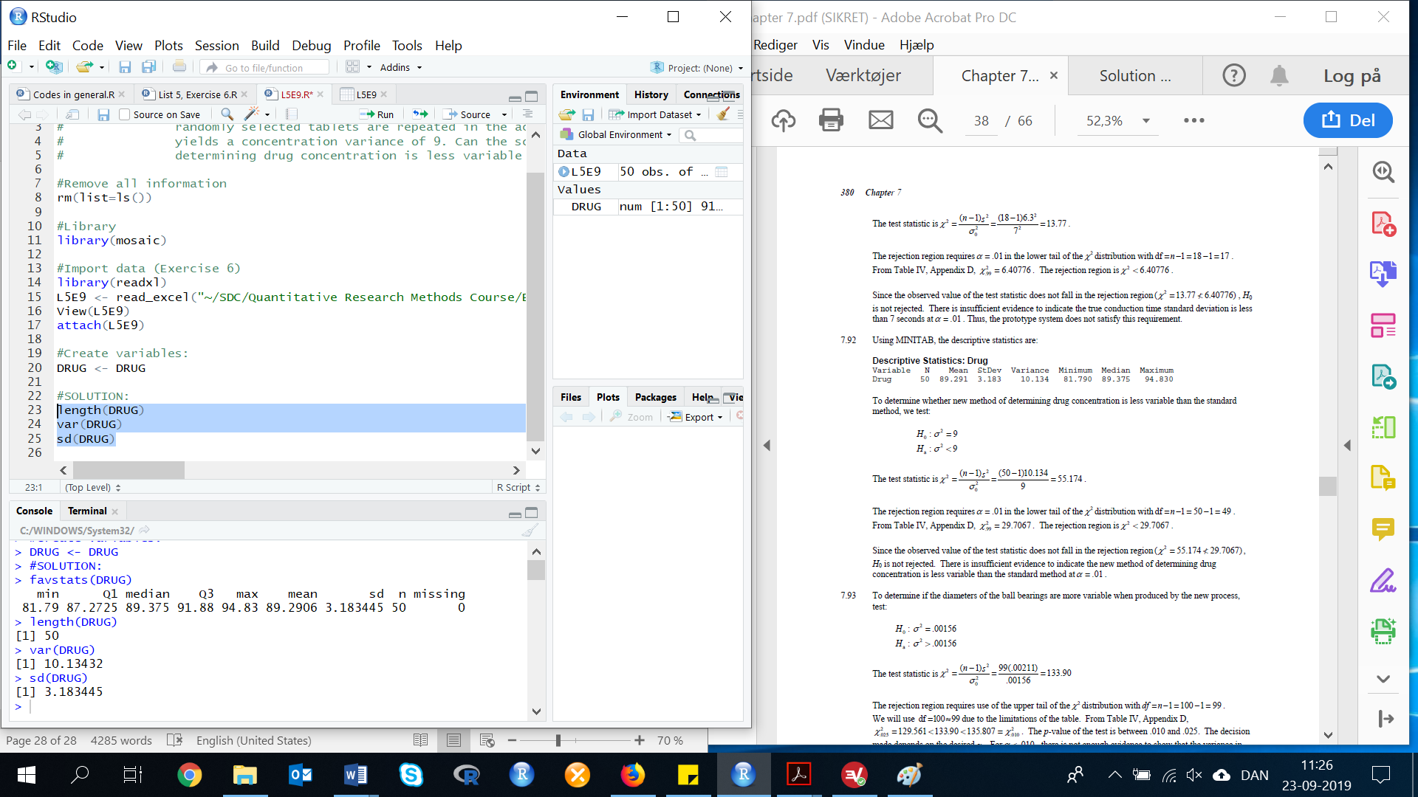length(DRUG)

var(DRUG)

The test statistic is (see page 412-41 for more information):

$$X^{2}=\frac{\left(50-1\right)*10.13423}{9}=55.17525$$

In R:

((50-1)*10.13423)/9

X2=55.17525

The rejection region requires α=0.01 in the lower tail of the X2 distribution with df=n-1:

df=50-1 = 49

From the table, we can see that $X_{0.99}^{2}$ =29.7067. The rejection region is X2<29.7067.

Since the observed value of the test statistic does not fall in the rejection region (X2=55.174 differs from 29.7067), H0 is not rejected. There is insufficient evidence to indicate the new method of determining drug concentration is less variable than the standard method at α=0.01.